A REVIEW OF CURRENT RESEARCH ON MENTAL ILLNESS AND METHODOLOGY WITH ITS TREATMENT
Summer Internship Program(SIP)
Submitted in Partial Fulfilment of the Requirements for the Degree of
B.A. (Honours) APPLIED PSYCHOLOGY

Submitted By
AAHELI ADHIKARY
Enrollment No: A91306920114
Batch: 2020-2023

Faculty Guide:
Dr. Rita Karmakar

Amity Institute of Psychology and Allied Sciences
AMITY UNIVERSITY KOLKATA
August 2022

DECLARATION

I, AAHELI ADHIKARY, bearing Enrollment No. A91306920114, hereby declare that the Summer Internship Project Report titled “A REVIEW OF CURRENT RESEARCH ON MENTAL ILLNESS AND METHODOLOGY WITH ITS TREATMENT” submitted by me, in partial fulfillment of the requirements for the award of the Degree of B.A. Honors in Applied Psychology from Amity University, Kolkata, is based on original research work carried out by me. This work is original and has never been submitted in part or full for any other degree or diploma of any university or institution.

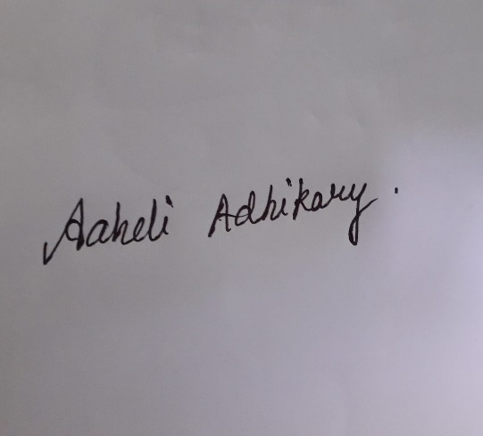

AAHELI ADHIKARY
A91306920063
B.A. (Honours). Applied Psychology,
Semester: 5, Batch: 2020-2023 Amity Institute of Psychology and Allied Sciences,
Amity University, Kolkata.

CERTIFICATE

This is to certify that the Summer Internship Project report on “A REVIEW OF CURRENT RESEARCH ON MENTAL ILLNESS AND METHODOLOGY WITH ITS TREATMENT”, has been submitted by, Enrolment No: A91306920114, Student of B.A. (Honours). Applied Psychology, Semester 5, Batch: 2020-2023, Amity University, Kolkata.
This project is in partial fulfillment of the requirement for the Degree of B.A. (Honours)in Applied Psychology, Amity Institute of Psychology and Allied Sciences, Amity University, Kolkata.

DR. RITA KARMAKAR
Assistant Professor,
Amity Institute of Psychology and Allied Sciences,
Amity University, Kolkata.

TABLE OF CONTENTS

TOPIC | PAGE NO.
ACKNOWLEDGMENT | 5
BACKGROUND | 6
ABSTRACT AND INTRODUCTION | 7-8
OBJECTIVE AND REVIEW OF LITERATURE | 8-12
METHODOLOGY | 12-16
RESULTS | 16-17
DISCUSSION | 18-23
CONCLUSION | 23
REFERENCES | 23-24

ACKNOWLEDGMENT:
I am sincerely thankful to Amity University, Kolkata, for providing me with the opportunity for the summer internship program.
Fine and foremost, praises and thanks to God, the Almighty, for
His showers of blessings throughout my term paper to complete it successfully.
I would like to express my gratitude to my mentor and guide, DR. RITA KARMAKAR, Professor, Amity University, Kolkata. Her dedication and keen interest above all her overwhelming attitude to help her students had been solely and mainly responsible for completing my work.
I owe a deep sense of gratitude to Dr. Rita Karmakar, Department of Applied Psychology, Amity University, Kolkata, for her prompt inspiration, timely suggestions, enthusiasm, and dynamic attitude towards the Summer Internship Program.
I am would like to express my gratitude to my family and all the patients and participants for the encouragement which helped me in the completion of this program.
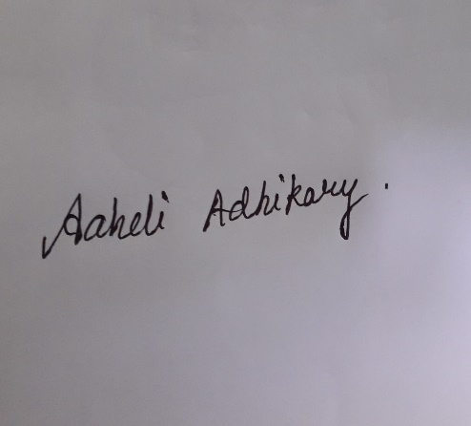

AAHELI ADHIKARY
(A91306920114)
B.A. (Honours). Applied Psychology,
Semester: 5, Batch:2020-2023
Amity Institute of Psychology and Allied Sciences,
Amity University, Kolkata
Background: Mental health is a state of mental well-being that enables people to cope with the stresses of life, realize their abilities, learn well and work well, and contribute to their community. It is an integral component of health and well-being that underpins our individual and collective abilities to make decisions, build relationships and shape the world we live in. Mental health is a basic human right. And it is crucial to personal, community, and socio-economic development.
Mental health is more than the absence of mental disorders. It exists on a complex continuum, which is experienced differently from one person to the next, with varying degrees of difficulty and distress and potentially very different social and clinical outcomes.
Mental health conditions include mental disorders and psychosocial disabilities as well as other mental states associated with significant distress, impairment in functioning, or risk of self-harm. People with mental health conditions are more likely to experience lower levels of mental well-being, but this is not always or necessarily the case.
Abstract:
INTERNSHIP PROGRAM DETAILS:
Company Name: Antara Psychiatric Hospital and Rehabilitation Centre
Company’s Name and Address: Antara Psychiatric Hospital and Rehabilitation Centre Hariharpur, P.O. Dakshin Gobindapur, P.S. Baruipur, Kolkata, West Bengal-700145
Contact Number: Ph. (O) 033 2437 0593/0439 (R) 903884412 Mobile: 9038844124
E-mail: antaragram365@gmail.com
Faculty Guide’s Name: Dr. Rita Karmakar
Industry Guide’s Name: Ms. Indrani Chakraborty (CHIEF CLINICAL PSYCHOLOGIST)
Internship Mode: Offline
Topic: Clinical and Rehabilitation with Occupational therapy
Project Objective: To get a brief idea about how the IPD system works, OPD management, and learning about case histories and mental status examination. Attending the patients and taking a note of the diagnosis, treatment, and future planning. Attending therapy sessions(occupational, rehabilitation). Working on a research paper and PowerPoint slides on criteria and classification from ICD and presenting the case. Visiting psychiatrists, psychologists, and social workers to get an idea about the process and findings of the patient.
Methodology to be adopted: The methodology used while presenting the report was a case study, case history and MSE with Open-ended questions with possible breaks in between with of 30 mins(twice a week). Followed a particular pattern provided by the hospital itself and we were given 5 classes for training. Psychiatrists psychologist and ,Medical health care professionals were a big support during the process.

Brief Summary of the project: "Removing illness and developing wellness".
The main aim of the internship was to get an insight into tental health issues and how it gets the tment and the procedures for it. Regular check upscheckupstoring the patienof ts, timely medication,ns and doctor visits with the counselor if required. Got to visit 8-9 different wards and had a discussion with the patients and the ward-in-charge about the problems and took possible case histories and mental status eexaminationsif possible. Visiting computer(infotech) classes and occupational training program with day care activity. Presented a case and was evaluated based on the presentation skills and other factors(behavior, time management). Antara psychiatric hospital and rehabilitation centre believes in removing the problem and attaining the peace and mental stability through different processes and programs. "Lightning a candle in the darkness"

INTRODUCTION
Increasing complexities of modern life are creating more problems for the human mind to cope with. Mental illnesses, including drug addiction, are assuming greater proportions as challenging social problems. With the superfast pace of technological advances and the associated social upheavals, the human mind is challenged with unprecedented demands for adapting appropriate coping mechanisms. The emerging scenario calls for urgent and adequate steps for mental health promotion, prevention of mental illness, treatment, care, and rehabilitation services. Antara is a response to this challenge. We strive to extend a helping hand to the man in mental distress.”. The Mission of ANTARA is to alleviate the suffering of people afflicted with mental illness, addiction, and alcoholism, especially the destitute. ANTARA shall strive to do this with love, patience, and compassion.
Aim and objective: Lighting a candle rather than cursing the darkness
Review of Literature: People suffering from severe various mental illnesses such as depression, anxiety, schizophrenia, or even eating disorders may need to spend some time in psychiatric words so that their disorders can be addressed. When one is experiencing psychosis symptoms, it is advisable to visit a mental facility before the problem can advance to stages that may have serious negative consequences. Mental illnesses should not be ignored for a long time because this may cause further complications.
According to Sharfstein and Oldham (78), psychiatric wards are beneficial if one visits them at the early stages of mental problems. At these early stages, one would only need proper counseling or minor treatment. The main problem that society faces is that it may not be easy to determine when it is the right time to visit these facilities.
Our government has invested a lot in psychiatric hospitals in terms of the workforce and the machines used in the treatment process. These facilities are meant to help address any form of psychosis among the citizens of this country. It is the responsibility of the members of our community to identify cases of mental problems and to visit these facilities as early as possible. This research paper will look at the activities, which take place in psychiatric hospitals. Psychiatric hospitals play an important role in addressing a variety of mental problems. At this stage, it will be important to analyze some of the important processes, which take place within these hospitals
Admission into psychiatric wards
Admission into a psychiatric ward is the first stage when one visits the facility. According to Thienhaus (113), admission can be made voluntarily or involuntarily. Voluntary admission takes place when one makes a personal decision to visit psychiatric hospital to help in addressing a mental problem. Such a person will visit the facility voluntarily and explain his or her problems that are causing mental stress.
Voluntary admission is the most recommended form of getting into the psychiatric wards because the mental problems are at the initial stages. That is why one can make a rational decision to look for a solution before the problem gets out of hand. However, Stern (90) says that this is the least common form of admission in most mental hospitals.
This is so because people always live in denials. When one starts experiencing mental stress, there is always a belief that the problem will disappear after some time. Very few people would admit that they have mental problems for fear of victimization at work or within the family.
The second and most common form of admission is involuntary admission. In this case, a person will be taken to a mental hospital against his or her own wish. Sometimes they are taken to these facilities without their knowledge. This happens when the mental problem is pronounced. The affected person may become a threat to members of the community or even to him or herself. At this stage, family members and friends will be forced to take the patient to a psychiatric hospital so that the problem can be addressed.
Activities within the wards
When one has been admitted into the psychiatric wards, a series of activities will take place to ensure that the problem is addressed. This will depend on the condition of the patient. When the mental problem is at an advanced stage, and the patient is violent, it may be necessary to give injections to help calm him or her calm down.
According to Carson (48), in cases where a patient is physically aggressive, the doctors may be forced to chain him or her at the bed in order to protect the medical team and other patients who are in the process of recovery. Such a patient may have to spend most of his or her initial days at the hospitals in seclusion for the purpose of the safety of others. The psychiatrist will monitor such a patient for a given period as he or she gets medication.
The psychiatrist will need to ensure that the condition of the patient has remarkably improved before such a patient can be allowed to mingle freely with other patients. According to Sharfstein and Oldham (56), cases, where patients attack and injure or even kill medical staff or fellow patients in psychiatric wards, are not unique. This means that before transferring a physically aggressive patient from seclusion to general wards, care should be taken to ensure that they do not pose any threat to the people around them.
Group discussion is always used among patients who are in their path to recovery. According to Carson (97), in most of cases, people who suffer severe mental problems always have a feeling that their problem is unique. However, when they are allowed to share their life experiences, they come to realize that their problem is not unique.
In fact, some may come to realize that their problem is minor compared to what others are facing. This eases the burden in mind. It helps in eliminating the stressor that causes mental problems. Such discussions also help the patient to forget about past problems. This is very important in speeding up the recovery process.

Individual therapy is another important activity within the psychiatric wards. In such sessions, the patient will have a one-on-one counseling session with a psychiatrist, psychologist, counselor, or social worker. The patient gets to share all the issues that cause stress in his or her personal life. The officer will listen to the problem and offer advice on how the patient will manage the problem. The focus of the officer will be to eliminate the stressors. It may not be possible for the officer to change a given fat that is causing stress.
For instance, if a person loses a loved one is a tragic manner, it is important to note that this is a fact that cannot be changed. However, the officer will introduce a new perspective on this issue in order to make the patient realize that his or her case is not unique. The aim is to help the patient learn to live with this sad fat without being consumed by stress associated with it.
When one is within the psychiatric wards, he or she gets personal time to meditate over the issues causing stress. According to Thienhaus (83), personal meditation is one of the best therapeutic processes that are used in helping mental patients to overcome their problems.
They are allowed to think and put everything into perspective. This way, they can figure out how they can make a personal effort to manage their problems. Patients suffering from mental problems are also allowed to have quality time with their family members. This makes them feel comfortable, a fact that enhances the healing process.
Discharge Planning
When a patient’s condition has improved considerably, the psychiatrist will need to determine whether he or she can continue with the medication as an outpatient. According to Stern (45), the family environment is very important in improving the healing process. However, this can only be done when it is confirmed that the stressors that affected the patient are not prevalent at home because this may worsen the condition of the patient.
When discharging the patient, the doctors will need to ensure that he or she is in the path of recovery and that the patient will not be a threat to family members or self. There will be a program to be followed by family members to ensure that the patient makes regular visits to the hospital so that his or her condition is monitored. In other cases, a nurse may make regular visits to their homes to monitor their progress.
Methodology: The methodology adopted while taking and following the case presentation and report write-up is CASE HISTORY & MENTAL STATUS EXAMINATION(MSE).

HISTORY TAKING:

- SOCIODEMOGRAPHIC DETAILS:
NAME: SM
SEX: Female
AGE: 22
ADDRESS: Bandal , Howrah.
MOTHER TONGUE: Bengali
EDUCATION: HS passed
RELIGION: Hindu
RESIDENCE: Kolkata
FAMILY TYPE AND SIZE: Nuclear
INCOME: 7.2 LPA(family income)
MARITAL STATUS/OCCUPATION(if any): nil

- PATIENT’S REPORT:
(SUICIDAL TENDENCIES AND ATTEMPTS)*
CHIEF COMPLAINTS: sleep disturbance, poor appetite, aggressive, suspiciousness, destructiveness, strong grudge, running away, too much speaking, poor compliance, mood swings, impulsive.
HISTORY OF PRESENT ILLNESS(HOPI): As per the client, she is suffering from mental illness last 5 years and it showed gradual onset. Started in 2016, and visited Dr, Ram but the family discontinued. Again, visited a neurologist in Amri Hospital which also didn’t work. Back in 2018, the client visited Dr. Alakananda Dutt, Dr. P.K. Saha and Dr. Sujit Sarkhel. The treatment started but the patient refused to take medicine. Symptoms increased.
Stressor/precipitating factor- when she had her operation for gall bladder in 2016.
Mode of onset- Sudden
Course- Continous
Progress- deteriorating
*SUICIDAL ATTEMPTS: According to the patient, she didn’t want to attempt, she wanted to threaten her family. She took PEM 650 and told her parents she attempted suicide. She left home and sat in a railway station all alone just to scare her family and let her father realize the love and the money she needs for her education.

- BIOLOGICAL FUNCTIONING:
SLEEP: disturbing
APPETITE: Normal
SEXUAL INTEREST AND ACTIVITY: no interest
ENERGY: deteriorating

- INFORMANT’S REPORT
(According to the case history file)
Name: Pijush Kar Mondal
Relationship with the patient: Father
Duration of relationship: since birth
CHIEF COMPLAINTS(according to file): sleep disturbance, poor appetite, aggressive, suspiciousness, destructiveness, strong grudge, running away, too much speaking, poor compliance, mood swings, impulsive.
HOPI: As per the family, she is suffering from mental illness last 5 years and it showed gradual onset. Started in 2016, the treatment started but the patient refused to take medicine. Symptoms increased. Under Dr, Sujit Sarkhel.
BIOLOGICAL FUNCTIONING: disturbed
TREATMENT HISTORY:
- Started in 2016, and visited Dr, Ram but the family discontinued. Again, visited a neurologist in Amri Hospital which also didn’t work. Back in 2018, the client visited Dr. Alakananda Dutt, Dr. P.K. Saha and Dr. Sujit Sarkhel.
- Medicines unknown(patient isn’t aware)
- Wanted therapy and treatment but family refused.

PAST ILLNESS(Reported by the patient):
- MEDICAL: Gall bladder operation, migraine, sinus.
- PSYCHIATRIC: Not yet diagnosed

FAMILY TREE: Three-tier family generation





FAMILY HISTORY OF PSYCHIATRIC ILLNESS: The paternal family has a history of psychiatric illness(details unknown)

- PERSONAL HISTORY:
Birth and developmental history-
Type of birth: cesarean section
Birth complications: head twisted while birth
Milestones: on time
- Childhood disorders- gall bladder problem in 2016, migraine and sinus
- Parents and home atmosphere in childhood and adolescence: Parental beating, Financial trouble, issues with extended family, father’s tendency on being aggressive.
- Scholastic history:
Highest grade completed- HS passed
Academic performance- well scored, more than 90%
Reason for discontinuation- a medical condition
Peer relationship- stable
Any discrepancy problem- sleep schedule trouble due to educational pressure.
Hobbies and interests- drawing, listening to music, going out.
- Interpersonal relations and social activities: disturbed
- Occupational history: worked online in affiliate marketing for 3 months
- Menstrual history
Menarche: 2013
Date of LMP: 01/08/2022
Regular/irregular- regular
Duration- 3 to 4 days
Any associated physical or psychological symptoms- PCOD

- Sexual history: had sexual intercourse back in 2019
- Marital history: nil
- Hobbies and addictions: Alchohol and Tobacco
- Legal History: nil
- Premorbid personality-
Attitude towards self: positive
Sociability: fluctuates
Responsibility taking: Positive
Predominant mood: stable
Adjustment: Positive
Attitude towards criticism: Accepted

MENTAL STATUS EXAMINATION(MSE):

- Appearance – well groomed, good sitting posture
- Behavior- well mannered, proper psychomotor activity, has expression, has eye contact, can follow commands/requests
- Level of Consciousness – not drowsy, not comatose, alert about situations
- Orientation – could answer every question asked about basic details.
- Speech and Language- spontaneous, no paucity.
- A. Quantity – stable
- B. Rate – Normal
- C. Volume (Tone) – soft
- D. Fluency and Rhythm – clear with no hesitation
- Mood (Inquired): the sustained state of inner feeling was stable, was in a low mood for a few days but not angry or irritated.
- Affect: an observed expression of inner feeling was labile and intensity was normal. Consistent with their mood and congruent with thought contents.
- Thought Processes or Thought Form: goal-oriented, no blockage as such.
- Thought Content: the possible question asked to the patient had a positive outcome. It was a stable condition and no hallucinations or harm were present.
- Suicidality and Homicidality: According to the possible questions, she used to get the feeling of life isn’t worth but with time and space, she realized and now she doesn’t have any suicidal or homicidal tendencies.
- Insight and Judgment: Stable and well answered. Thinking about future plans even.
- Attention: concentration level low.
- A. Digit Span (forward and reverse) – according to the suggested instructions, she performed well.
- B. Spelling Backwards – she missed 1 count but tried.
- C. Calculations – tried and succeeded.

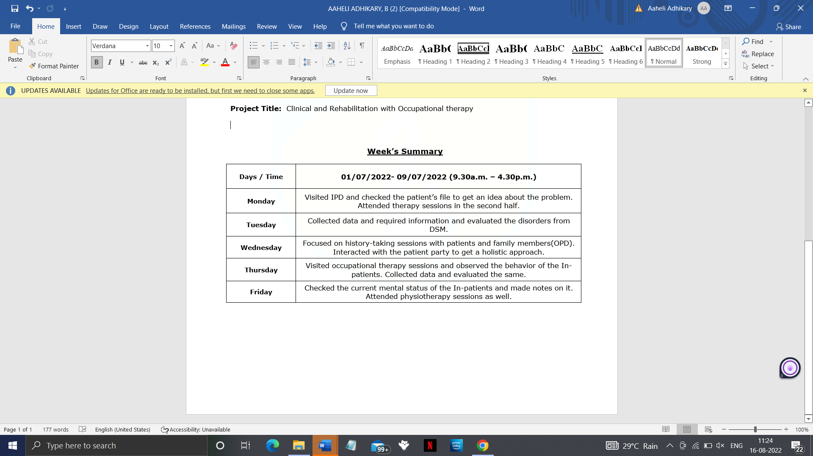
- Results: The weekly progress report summarization, gained from the summer internship program 2022. Antara hospital played a big role in learning and achieving insight through practical and theoretical exposures.

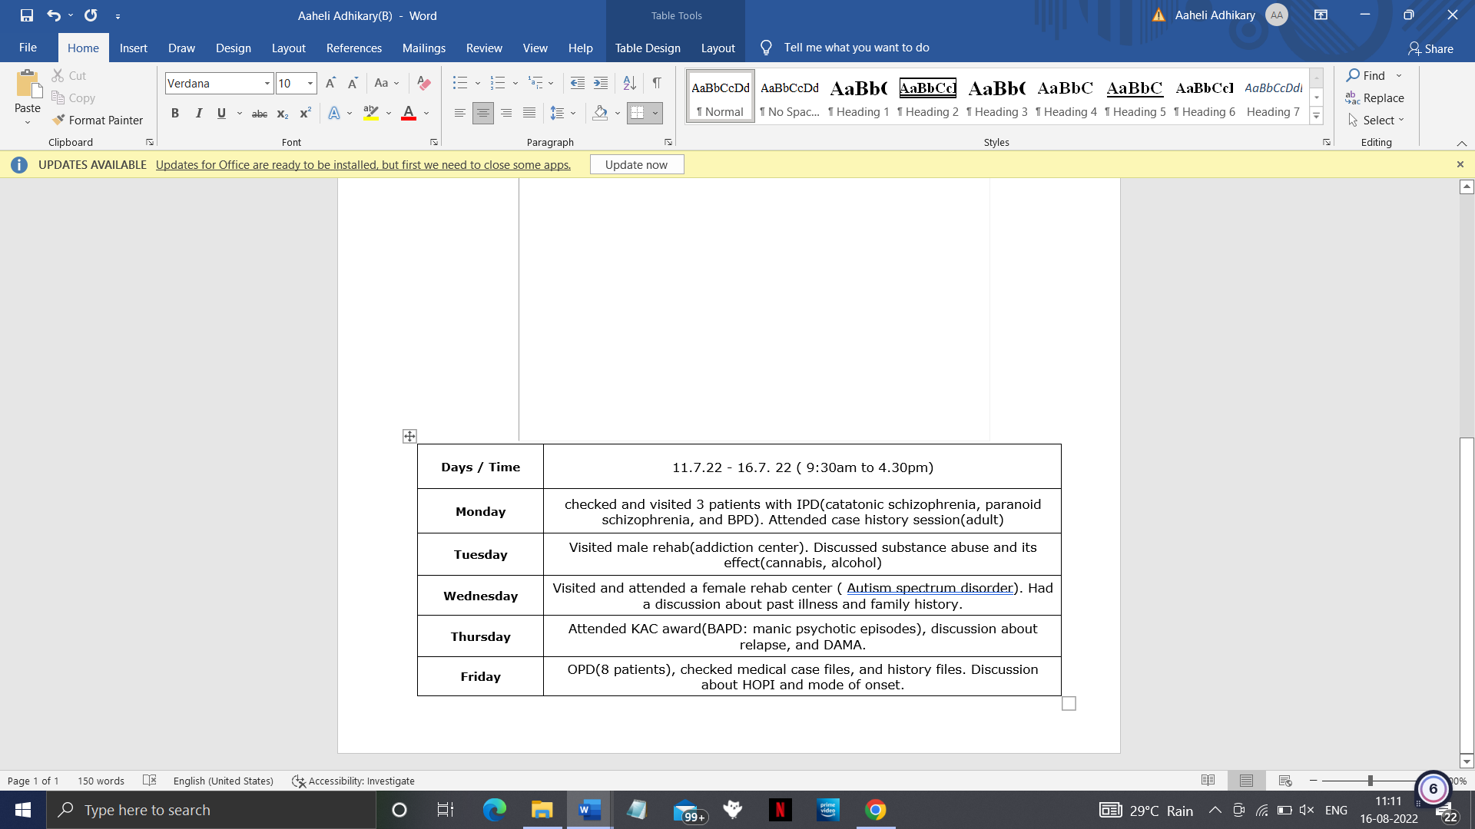

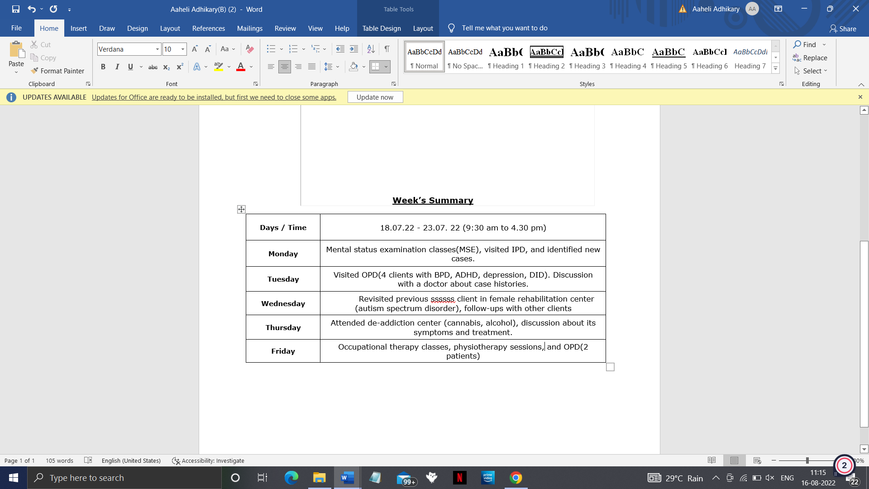

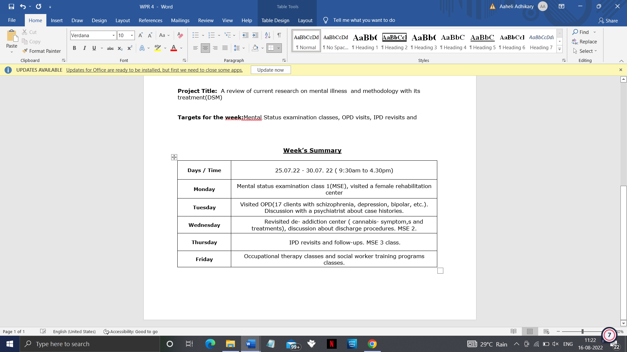

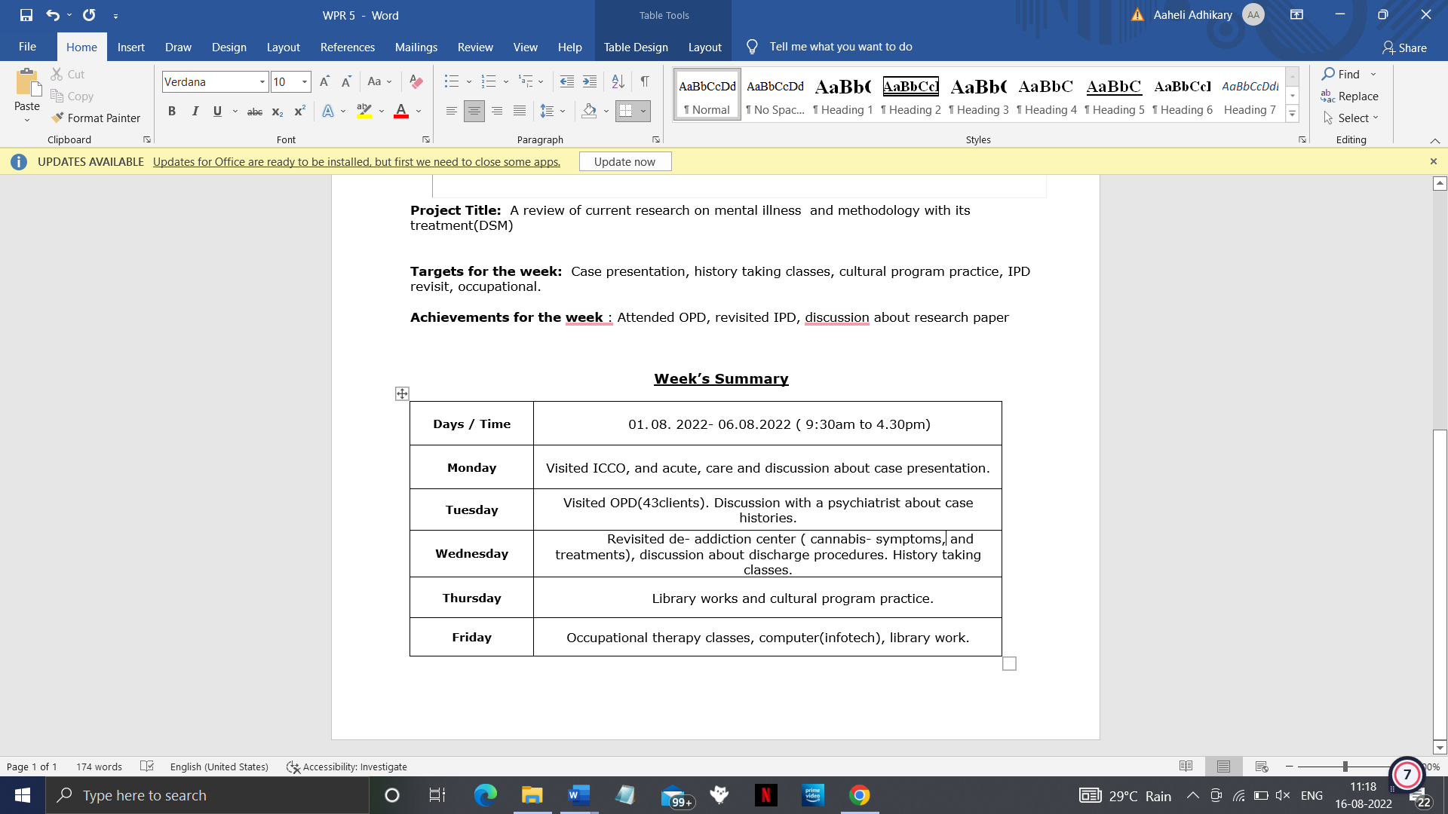

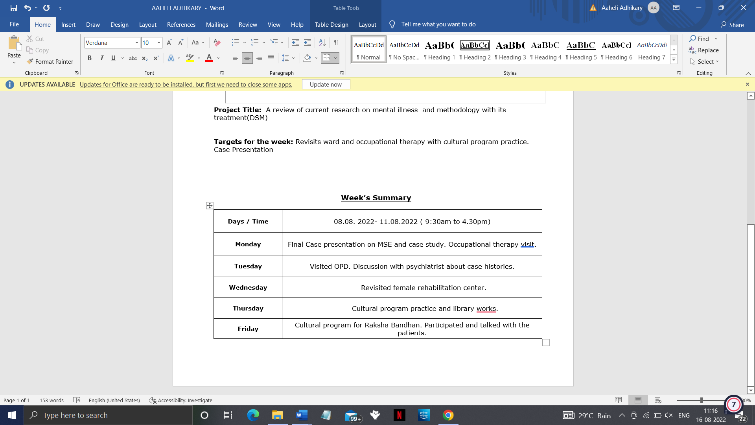

- Discussion: Throughout our lives, multiple individuals, and social and structural determinants may combine to protect or undermine our mental health and shift our position on the mental health continuum.
Individual psychological and biological factors such as emotional skills, substance use, and genetics can make people more vulnerable to mental health problems. Exposure to unfavorable social, economic, geopolitical and environmental circumstances – including poverty, violence, inequality and environmental deprivation – also increases people’s risk of experiencing mental health conditions. Risks can manifest themselves at all stages of life, but those that occur during developmentally sensitive periods, especially early childhood, are particularly detrimental. For example, harsh parenting and physical punishment is known to undermine child health and bullying is a leading risk factor for mental health conditions. Protective factors similarly occur throughout our lives and serve to strengthen resilience. They include our individual social and emotional skills and attributes as well as positive social interactions, quality education, decent work, safe neighbourhoods and community cohesion, among others.
Mental health risks and protective factors can be found in society at different scales. Local threats heighten risk for individuals, families and communities. Global threats heighten risk for whole populations and include economic downturns, disease outbreaks, humanitarian emergencies and forced displacement and the growing climate crisis.
Each single risk and protective factor has only limited predictive strength. Most people do not develop a mental health condition despite exposure to a risk factor and many people with no known risk factor still develop a mental health condition. Nonetheless, the interacting determinants of mental health serve to enhance or undermine mental health.
Mental health promotion and prevention
Promotion and prevention interventions work by identifying the individual, social and structural determinants of mental health, and then intervening to reduce risks, build resilience and establish supportive environments for mental health. Interventions can be designed for individuals, specific groups or whole populations. Reshaping the determinants of mental health often requires action beyond the health sector and so promotion and prevention programmes should involve the education, labour, justice, transport, environment, housing, and welfare sectors. The health sector can contribute significantly by embedding promotion and prevention efforts within health services; and by advocating, initiating and, where appropriate, facilitating multisectoral collaboration and coordination.
Suicide prevention is a global priority and is included in the Sustainable Development Goals. Much progress can be achieved by limiting access to means, responsible media reporting, social and emotional learning for adolescents, and early intervention. Banning highly hazardous pesticides is a particularly inexpensive and cost-effective intervention for reducing suicide rates. Promoting child and adolescent mental health is another priority and can be achieved by policies and laws that promote and protect mental health, support caregivers to provide nurturing carand e, and implementing school-based programs improve the quality of community and online environments. School-based social and emotional learning programs are among the most effective promotion strategies for countries at all income levels.
Promoting and protecting mental health at work is a growing area of interest and can be supported through legislation and regulation, organizational strategies, manager training, and interventions for workers.
Mental health care and treatment
In the context of national efforts to strengthen mental health, it is vital to not only protect and promote the mental well-being of all but also to address the needs of people with mental health conditions.
This should be done through community-based mental health care, which is more accessible and acceptable than institutional care, helps prevent human rights violations and delivers better recovery outcomes for people with mental health conditions. Community-based mental health care should be provided through a network of interrelated services that comprise: mental health services that are integrated into general health care, typically in general hospitals, and through task-sharing with non-specialist care providers in primary health care; community mental health services that may involve community mental health centers and teams, psychosocial rehabilitation, peer support services and supported living services; and services that deliver mental health care in social services and non-health settings, such as child protection, school health services, and prisons.
The vast care gap for common mental health conditions such as depression and anxiety means countries must also find innovative ways to diversify and scale up care for these conditions, for example through non-specialist psychological counseling or digital self-help.
- Conclusion:
Psychiatric hospitals are very important for patients suffering from mental problems. Society has a negative impression of these institutions. While others feel that they are forms of prison, others consider them as institutions for the mad people. This negative impression limits the ability of people to take the personal initiative to visit these facilities. However, the truth is that psychiatric hospitals are meant for anyone with a mental problem that may alter their normal behavior. The earlier one visits these facilities, the higher the chances of getting better
- Implications:
World Mental Health Day is coming up. Each year on October 10th, countries all over the world observe this day and work to bring awareness to mental health and the significant impact it has on people’s lives. October 10th became World Mental Health Day in 1992 when The World Federation of Mental Health (WFMH) began commemorating with a global broadcast covering mental health themes. In 1994, the WFMH started the tradition of choosing a theme each year. This year, the theme is mental health in an unequal world. The goal of this theme is to raise awareness of the issues of inequality in mental health. Those issues include the lack of mental health services available to people living at or below the poverty line, and the stigma surrounding mental illness in marginalized communities.
To celebrate World Mental Health Day this year, you can learn about mental health issues and how you can spread awareness. The more you help raise awareness of the problem, the more we can decrease the worldwide mental health stigma. Here’s how you can participate:
Check-In With Yourself And Your Loved Ones
It’s important to check in on mental health regularly, but it’s common to get caught up in a busy schedule and forget about it. Mental health day is the perfect reminder to get back in the habit of regularly checking in with yourself and your loved ones. To check in on yourself, simply start by asking yourself a few questions. You might want to journal and reflect on these questions if that helps you think more deeply. Ask yourself the following questions:
- How am I feeling lately?
- Has anything been adding to my stress levels recently?
- Am I taking care of my body?
- Am I taking time to do things I love?
- Who can I lean on when I need extra support?
If any of these questions reveal that you’re not feeling mentally healthy, it’s a good time to think about what you can do to improve your mental health. That could mean taking more time for self-care, looking for peer support groups, or seeking professional treatment for a mental illness.
If you’re not sure about the answers to these questions, you may want to consider reaching out to a mental health provider to discuss what you can do to improve your ability to check in with yourself. To check in with your loved ones, ask these same questions. Let them know they can turn to you if they need support.
Become More Informed And Spread Your Knowledge
There’s never a better time than Global Mental Health Day to spend time researching mental health issues. There are so many resources online that can teach you about mental health. You might want to research the link between mental health and addiction, or you might be more interested in learning about how to support a suicidal friend. Spend time learning about any issue that is most interesting to you. Once you’ve learned about an issue, be sure to share your new knowledge. Social media is an awesome tool for sharing facts, statistics, and helpful tips. You can also bring up what you’ve learned with friends and family members and encourage them to do their research if they’re interested.
Donate or Volunteer With Mental Health Organizations
An excellent way to celebrate World Mental Health Day is by supporting organizations that work with people with mental illness or organizations that work to raise awareness of the mental illness. You can support these organizations through monetary donations, but if donations aren’t in the budget right now, you can still support them! Many organizations rely on volunteers to keep their operations going. Reach out to your favorite mental health organizations to see how you can help. Consider supporting the World Federation for Mental Health or find a Mental Health America affiliate. If you already know of a mental health organization in your area that you admire, reach out and ask what kind of help they need.
Coordinate an Event
There are numerous types of events that promote positive mental health and spread awareness of the mental illness. You can coordinate a mental health fair that shares resources and information on mental health. You could also hold a mental health screening event. Many people don’t realize they are living with a mental illness, and that they can receive treatment to feel better. A mental health screening can help those people get the support they need. You could even combine your screening event with your mental health fair. There are online resources for mental health screenings. Simply set up a booth with internet access at your mental health fair and encourage people to take an online screening test.
Decreasing The Stigma
Our own experience is the number one tool you have for decreasing the stigma surrounding mental health. According to the CDC, more than 50% of people will be diagnosed with a mental health disorder at some point. This means that even if you don’t struggle with mental illness currently, it’s almost a guarantee that you have a loved one who does. If you have permission from your loved ones with mental illnesses, you can share those experiences too. Don’t be afraid to speak about mental health experiences at work, school, with friends, or even at family gatherings. To reach a wider audience, you can share on social media, in a blog post, or even in a letter to the editor of a local newspaper. The more people you reach with your story, the more you’ll be able to impact your community for the better.
When people notice how common mental illness is, they become less afraid of it. Sharing your experience can show others how it is possible to live a fulfilling life even with a mental illness. You can also talk about what you did to cope with your mental illness, as many people are unaware of anything they can do to feel better. As you speak up, more people will realize that it’s okay to experience mental health issues

- References:

- Coccia, M., and Wang, L. (2016). Evolution and convergence of the patterns of international scientific collaboration. Proc. Natl. Acad. Sci. U.S.A. 113, 2057–2061. Doi 10.1073/pnas.1510820113
- Antaramian, S. (2015). Assessing psychological symptoms and well-being: application of a dual-factor mental health model to understand college student performance. J. Psychoeduc. Assess. 33, 419–429, 10.1177/0734282914557727
- Coccia, M., and Wang, L. (2016). Evolution and convergence of the patterns of international scientific collaboration. Proc. Natl. Acad. Sci. U.S.A. 113, 2057–2061. DOI: 10.1073/pnas.1510820113
- Roche, GC, Fung, P, Ranking, R, The state of psychiatric research in the Asia Pacific region. Asia Pac Psychiatry, 2021;13: e12432. https://main.icmr.nic.in/sites/default/files/reports/Mental_Health.pdf (2021, accessed March 9, 2021).

